Question 1

Given:
Mass = 2.25 ± 0.021kg
Radius = 0.180 ± 0.0030m
𝜔 = 17.5 ± 0.250 rad/s
L = 1/2MR² 𝜔

Find:
The angular momentum 𝐿 and its uncertainty.

Diagram:
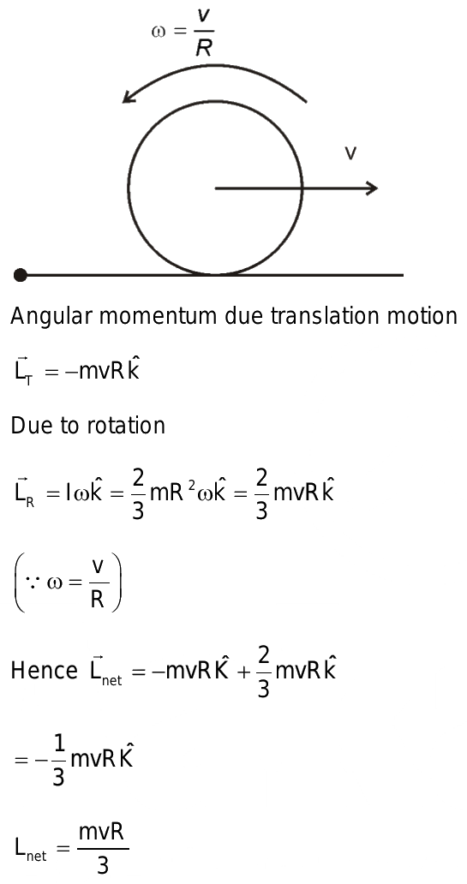

Theory: Propagation of error formula
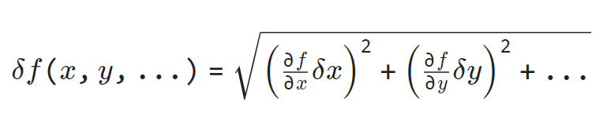

Assumptions: Uncertainties in mass, radius, and angular velocity are independent.

Solution:
$$L= \sqrt{{(0.5×17.5×0.021×{0.18}^{2})}^{2}+{(2.25×0.18×17.5×{0.003}^{2})}^{2}+{(0.5×2.25×0.25×{0.18}^{2})}^{2}}$$

L = 0.64 ± 0.02 kgm^2/s

Question 2

Given:
- $L=0.75±0.011m$
- $T=1.75±0.010s$

Find:
- What is the predicted value of T?
- Is a measured value of $T=1.75±0.010s$ is consistent with the theoretical prediction from part a.

Diagram:
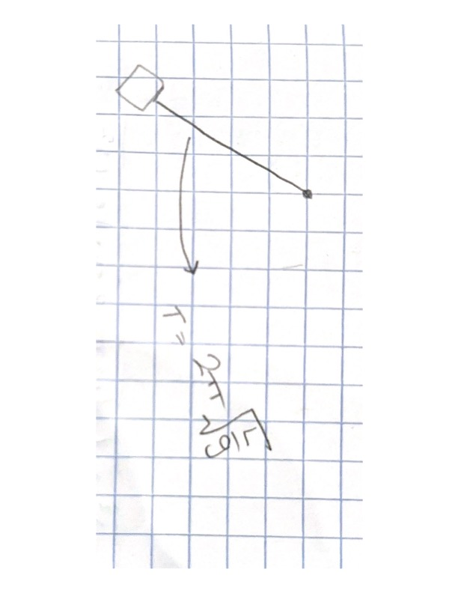
Theory:

- the period T of a simple pendulum is $T=2π\sqrt{\frac{L}{g}}$

Assumptions:

We can assume we will need to get the $L_{max}$ and $L_{min}$ values to compare to the theoretical prediction.

Solution:

Compute max and min values of the lengths

$$L_{max}=\left(0.75+0.011\right)m=0.761m$$
$$L_{min}=\left(0.75-0.011\right)m=0.739m$$

$T_{}=2π\sqrt{\frac{0.75}{9.81}}=1.738$ ; $T_{maximum}=2π\sqrt{\frac{0.761}{9.81}}=1.751$ ; $T_{minimum}=2π\sqrt{\frac{0.739}{9.81}}=1.725$

$T=1.75±0.010s$ -> Max = 1.76, Min = 1.74

Since $1.725≤T ≤1.751$, only the minimum value would fit here and the max value is not consistent.

Question 3

Given:
v1 = 3.54 ± 0.10m/s
v2 = 8.16 ± 0.10m/s
t = 2.79 ± 0.10 s
a = (v2-v1)/t

Find:
- Acceleration and its uncertainty.
- Compare the measured acceleration with the predicted.

Diagram:

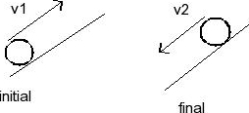
Theory: Propagation of error formula


Assumptions:
The uncertainties in v1, v2 and t are independent and random.
Solution:

$$a= \sqrt{{({2.79}^{-1}×.1)}^{2}+{({-2.79}^{-1}×.1)}^{2}+{(-\left(\frac{8.16-3.54}{{2.79}^{2}}\right)×.1)}^{2}}$$
L = 1.656 ± 0.08 m/s^2

Question 4

Given:
- 𝑚1 = 102 ± 1.0 grams
- 𝑚2 = 86 ± 0.90 grams

Find:
- Equation for the uncertainty in the expected acceleration (𝛿𝑎)
- Calculate 𝑎 ± 𝛿𝑎 using the given values

Theory:
- Formula for acceleration is:
  - $a= \frac{g*\left(m1-m2\right)}{(m1+m2)}$
- Formula for propagation of uncertainties:
  - $\frac{δa}{a}=\sqrt{({\left(\frac{δm1}{m1}\right)}^{2}}+{\left(\frac{δm2}{m2}\right)}^{2})$
Where:
- 𝛿𝑎 is uncertainty in the acceleration.
- 𝛿𝑚1 is uncertainty in mass 𝑚1.
- 𝛿𝑚2 is uncertainty in mass 𝑚2.

Assumptions: Masses m1 and m2 are independent measurements, there is no correlation between them.

Solution:

Solve for acceleration:
$a= \frac{g*\left(m1-m2\right)}{(m1+m2)}$ $a=\frac{9.81*\left(0.102-0.086\right)}{(0.102+0.086)}$ = 0.835 m/s²

Rearrange the propagation of uncertainties:
$$δa=\frac{g*\left(m1-m2\right)}{(m1+m2)} ×\sqrt{({\left(\frac{δm1}{m1}\right)}^{2}+{\left(\frac{δm2}{m2}\right)}^{2})}$$
$$δa=0.835 ×\sqrt{({\left(\frac{1.0}{102}\right)}^{2}+{\left(\frac{0.90}{86}\right)}^{2})}=0.014339 × 0.83489=0.012$$

𝑎 ± 𝛿𝑎 is approximately 0.835 ± 0.012 m/s².

Question 5

Given:
H = 3.20 ± 0.15
W = 5.00 ± 0.05
L = 4.25 ± 0.13

Find:
- The volume of the rectangular prism and its associated uncertainty.

Diagram:

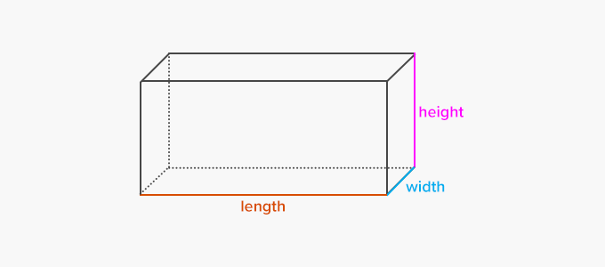
Theory: Propagation of error formula

Volume = Base x Height
Base = Length x Width
Assumptions:
Uncertainties in height, length, width are independent and random

Solution: 